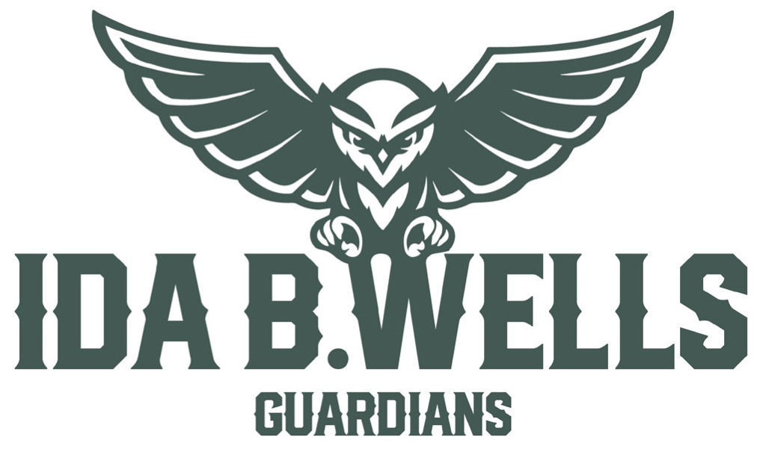

Athletics Weekly

“***My motto was always keep swinging. Whether I was in a slump or feeling badly or having trouble off the field, the only thing to do was keep swinging.”-*Hank Aaron**

**Greetings Sports Fans!** I would like to thank the Volleyball Program for embodying all that we are promoting with our Be A Guardian initiative. All three levels have been recognized by the OSAA for their outstanding sportsmanship. They win with gratitude, respect their opponents, and every one of them has been extremely helpful at all matches. Well done Guardian Volleyball Players! You are appreciated! Keep up the great work! Next up, we are entering the throws of league play for many of our programs. Our Varsity Volleyball Program is competing well in the PIL sitting alone in 1st place with some decisive victories over our opponents. In fact, the entire program is having success on the court. The Varsity will be traveling to Westview for an important tournament this weekend. Our Varsity Football Program went to McDaniel this past week and hammered out a win against the Mt. Lions. We have a big game this Friday at home against the Franklin Lightening. Both of our Varsity Soccer Programs wrap up a tough non-conference schedule this week then open up league play on Thursday. On Wednesday of this past week, we held our one and only Cross-Country Meet at Gabriel Park. What a great day for our program and community! Our runners did an outstanding job and a huge thanks to all the coaches and volunteers to make it such a great day! Our Cheer Program is gearing up for their first competitions of the year. It was great to see so many youth Cheerleaders at our youth Football games over the weekend. A huge shout out to our coaching staff for all of their work creating a balanced and inclusive program. Finally, thank you to all the parents who have been carpooling, attending games, working the snack shack, and supporting Ida B. Wells Athletics! You all are appreciated! Great time to be a Guardian!

**Resources & Reads**

A colleague of mine reached out and shared a really neat resource called Heroic. There are great resources surrounding ancient wisdom, positive psychology, mental toughness, habits, sleep, leadership, and many more. You can download the app or find more information at <https://www.heroic.us/optimize> If you are looking for a good read, Do Hard Things by Steve Magness is the latest book I picked up. Very good book with some really good insights.

**Schedules**

All of our schedules for the Fall season can be found at [www.ibwathletics.com](http://www.ibwathletics.com) and [www.osaa.org](http://www.osaa.org) as well.

**The PIL Open**

The PIL has done a tremendous job of supporting Middle School Sports for our league. We currently provide Middle School Sports for Volleyball, Football, Cross Country, Wrestling, Basketball, and Track and Field. One of the biggest ways we continue to support these efforts is playing in the PIL Open on September 28th at the Reserve. If you are interested in forming a team or becoming a sponsor, please visit [www.pilathletics.com](http://www.pilathletics.com) for more information.

**NFHS Network**

This is a reminder that all of our contests in the stadium and the gym are streamed on the NFHS Network. If you cannot make it to the game or have family abroad, this is a great opportunity to watch our contests. Please visit [www.nfhsnetwork.com](http://www.nfhsnetwork.com)

**IBW Boosters**

We can’t thank the Ida B. Wells Booster club for all of their hard work for all they do to support our community. And they can’t do it all without your support. They are always looking for new members and volunteers. Please visit <https://www.ibwboosterclub.org/> to find out more ways to support this great organization.

**Spotlight-Guardian Football**

A note from our Head Coach, Keith Bennett- Guardian Football is back, and better than ever!!  Our program has grown so much in the past three years!  This season we are playing 3 games per week as we have so many students playing football, we have three different teams competing.

We are not just competing, we are successfully competing.  Our Varsity team is on the right track winning two games and narrowly losing to perennial league power Grant in the last 10 seconds at their home turf.  We had them on the ropes and served notice to the rest of the league that we are for real.  Our JV team is currently undefeated after 3 games and playing some inspired football.  Our Freshman team played their 1st contest of the season last week and did a great job of coming together as a team.

Not only is our high school team growing, but our youth teams are as well.  We have the most kids playing youth football in the PIL.  We have a separate 8th and 7th grade team this season, which very few teams around the state have.  Because of this, our 7th and 8th grade teams will only play 1 other PIL school this season.  They have been moved into the toughest youth league in the state to compete with the biggest programs around the area.

Along with our success on the field, behind the scenes we are finally able to enjoy the experiences that can only be found playing football.  We travelled this summer down to Southern Oregon for our Summer Football Retreat.  We feed the players on every road trip and our Thursday Night Dinners are a huge success!  With three programs all playing football, we are going through a ton of food!  There is always room on our team for more players.  Now is the time to come out and play some football!!!

Football is back, Guardian Nation!  We can use your support.  Make plans to come out on Monday to cheer our JV teams on to victory, and of course always mark your calendars for Friday Night Football!  GO GUARDIANS!!!

**Spotlight-Cheer**

A note from our Head Coach, Lynsey Smith- So far this season cheer is off to a great start. We have 19 athletes between both green and white squads. In addition to cheering on our fellow guardian athletes in fall and winter seasons, we will be competing in both GameDay and traditional divisions in the coming months. We are also planning to compete at USA nationals in Anaheim in February. We are thrilled to have a very strong sophomore class of athletes in our program. And are glad to have senior captain, Kathleen Vaught back in action as she was out most of last year due to injuries. As always, it’s a great day to be a Guardian cheerleader!

**Spotlight-JV Volleyball**

A note from our Head Coach, Kurt Krueger- 2022's JV volleyball team is off to a terrific start let by team captains Haven Slocum and Kira Krueger.  They are fresh off a tense battle for the win against a very competitive McDaniel team going 5 sets on the road.  The lady Guardians have only given up one loss to a very good Grant team with the girls circling the calendar for a rematch on October 10th.  Middle blocker Carlotta D'Onofrio has been dominant at the net with key blocks in every set she has played.

**Spotlight-JV2 Women’s Soccer**

A note from our Head Coach, Kasey Gellar- So far this season has gone very well.  The JV2 Women's soccer team has played 6 games, and won 5 of those games. We have played Benson as our season opener and won 5-0 with all goals by freshman players.  We then travelled down to Canby and got down 0-2 early in the game but was able to rally back and win 3-2 with a game winning goal in the last 10 seconds by Freshman Nico Ashby-Eskew.  Our next couple of games against Lakeridge we won 2-0, and Benson again 1-0.  We then played Oregon City and had a tough loss with no goals on our end but rallied back to win 1-0 against Sunset at our home field.  We are looking forward to our next games against all League competition.

**Spotlight-Cross-Country**

A note from our Head Coach, Thor Esbensen- Guardian cross country is off to a historic start. We have 162 athletes excited to tackle the season. We have a fantastic group of returning athletes leading our amazing group of new athletes. We have had 5 contests so far and both teams look to challenge the best in the state. We greatly appreciate all the wonderful community support we received at our lone home contest. It was so inspiring for our athletes to see so many students, teachers, family members and alumni cheering them on!!

**Guardians of the Week**

**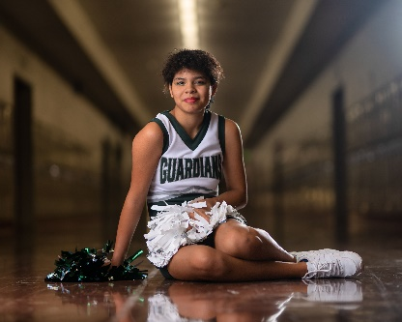**

**Cale Bartlett So. Cheer-** This is Cale’s first season in our program and while they’ve only been on the Green Squad a few months, they are already making a big impact! One thing that makes Cale such a valuable addition to our program is their high level of emotional intelligence and self-awareness. And given the length and intensity of the cheer season, these traits are especially desirable.  Cale is also a very strong stunter who performs with a lot of power and energy. Not to mention, they have a stellar sense of humor that both of the coaches and all of their teammates appreciate. Being that Cale is a part of a large sophomore contingent in our program, we know we can expect great things from them over the next three years.

**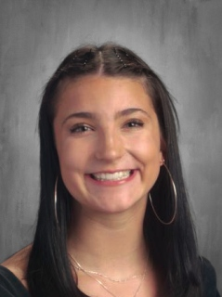**

**Eleanor Pigg Sr. Volleyball-** Leading the guardians in assists, aces and digs for the week, Eleanor was making plays per usual. Controlling the offense, hustling all of the court, setting up her hitters to finish the rally. Her leadership and command of all phases of the game has been great to see.

****

**Sylvie Heffron So. JV2 Women’s Soccer-** Sylvie Heffron is a great leader on and off the field, when the team is down she is always trying to keep the team motivated. At the game at Sunset she had many key defensive saves that helped secure the victory!

****

**Jack Carey Sr. Men’s Soccer-** Jack played through a muscle injury and sickness, leading the defensive line that only conceded two total goals last week. After scoring from a freekick last week in a disappointing loss to Jesuit, Jack captained the team to a late comeback tie against Lake Oswego and a 1-0 loss to a highly touted Lakeridge side. Jack has established himself as one of the premier defenders in Oregon and a contender for PIL defensive player of the year.

**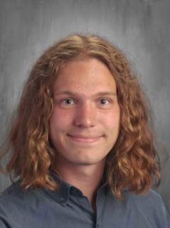**

**Orion Hess Sr. XC-** We cannot be Guardian XC without Orion Hess. His leadership is immeasurable. He is every bit a full time coach in our program. He leads drills, instructs others, comforts all and is the strongest pillar of our program. Orion leads with love and our team knows it.

**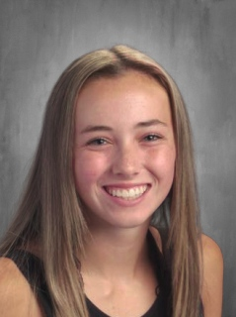**

**Lola Dixon Sr. XC-** Lola is the heart of our team. She fosters and creates the welcoming caring environment that we hold so dear. She is our leader, our listener, our hype woman and our inspiration. Lola inspires us all to be better Guardians in every way.

**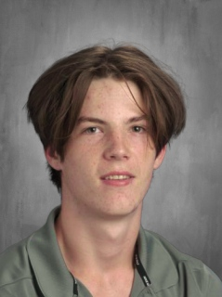**

**Emmett Davis Sr. Football-** Emmett was everywhere against McDaniel. An early touchdown on offense quickly followed by a punt return for a touchdown, a two-point conversion, and later an interception are just the headlines of a stat sheet that by itself grants Emmett player of the week honors. Consistently one of our hardest workers in practice and leaders on the field, no praise can be enough for one of our most talented seniors.

**Sunday Tid-Bits-**

**Resiliency-** You may think dark times are the worst times of your life, but the truth is that they teach you a lot of things you won't have had the privilege to learn if everything is all good. Dark times build resilience in you, they strengthen your weaknesses, shape your character, and help you find the courage to face whatever lies ahead. In those times, you can either choose to stand strong or cower in fear, to keep fighting or admit defeat, to look ahead with hope or look around with despair, in the end, your choices in times of adversity shape who you become. You must understand that what you are going through in the present is not where it all ends, but through it, a better you will emerge. Tough times don't always last, but take advantage of the times to develop toughness, for the journey is far, and when the dust comes down, only the strong will remain standing. Don't be too concerned and frightened by some negative or bad experience you have in life, inherent in them are lessons that will be useful in days to come.

## Finding Joy- We rob ourselves of joy because of the storylines we create around our painful

## challenges in life, be they physical, financial, mental, emotional, or spiritual. As we walk through the growth experiences of life's discomfort, we realize joy is right there in the midst of it all.

**The Journey Inward-**When we examine ourselves and have a deep sense of inquiry and reflection, we can begin to take back our power and instead of allowing cynical moods and habitual thoughts to determine our –

* Emotions
* Perceptions
* Experiences

When we look inward, we allow ourselves to make a different choice. Choice is a function of expanded awareness.

**It is never too late-**It is never too late to become fearless and step out of your comfort zone. Four ways to be a more courageous version of yourself-

1. **Acknowledge your fear:** Never try to sweep your fear under the rug. It will give it more power.
2. **Confront it:** Confronting your fear is about understanding the underlying reasons why you’re afraid in the first place.
3. **Use positive self-talk:** Self-talk is that inner voice inside your head that reveals your beliefs and thoughts. Consistent, positive self-talk will build your confidence and your ability to overcome your fears.
4. **Get comfortable being uncomfortable:** The best way to become fearless is to put yourself in situations that intimidate you. Once you do them despite being afraid, fear will lose power over you.

## The IBW Athletic Department would like to thank the following sponsors for their generous support.

## C:\Users\mnolan\Downloads\GB_LOGO_2560x720.png

## 

## 

The IBW Athletic Department is committed to supporting our student-athletes to thrive in the classroom, promoting character, fostering healthy competition, and building bridges in our community.